Kompozitní pořad před/v/po

# Tabulky TvImportItem, ProgrammeBlock a ProgrammeType (ten zmizi) před zmenou

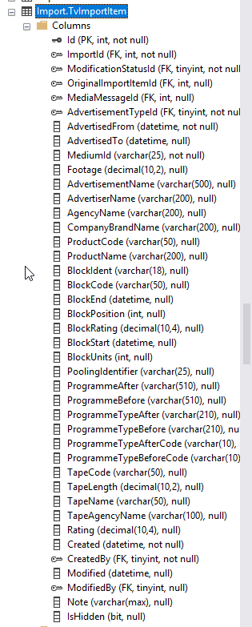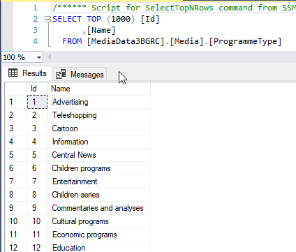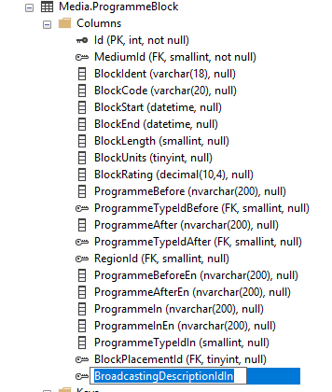

# Tabulky SimLogu

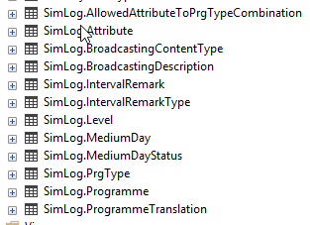

**AllowedAttribute** many to many tabulka



**Attribute** ciselnik

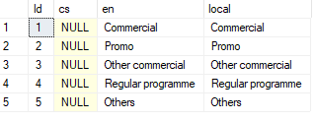

**BroadcastingContentType**  ciselnik



**BroadcastingDescription** vyskytyporadu



**IntervalRemark** znacky pro Zachytavadlo, aby holky vedely kde jsou reklamy



**IntervalRemarkType** ciselnik, jen jedna hodnota



**Level** ciselnik atomic composite

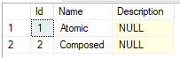

**MediumDay** jeden vysilaci den den jednoho media. Zacina o pulnoci, při nacitani v SimLogu tototo dne ale dostanu streamy od 6. hodiny do 6. hodiny nasledujiciho dne.



**MediumDayStatus** ciselnik

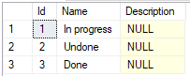

**PrgType** ciselnik, typ programu



**Programme –** program napr televizní noviny. Nejedna se o vyskyt ale o definici , ma nejaky typ – prgTypeId



**ProgrammeTranslation**



**Media.ProgrammeBlock - pribyly tri dolni sloupce**

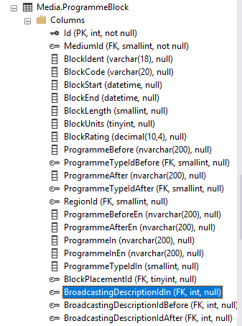

# Pridani ProgrammeDatacontractu do query (V TvImportItemDao je to ještě zrefakovane do jedne metody):

**TvMediaMessageDao.**

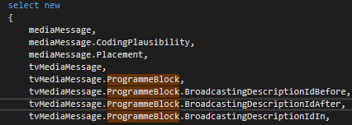

var data = queryable.ToArray();

List<int> programs = data.Where(d => d.BroadcastingDescriptionIdBefore != null).Select(d => d.BroadcastingDescriptionIdBefore.Value).ToList();

programs.AddRange(data.Where(d => d.BroadcastingDescriptionIdIn != null).Select(d => d.BroadcastingDescriptionIdIn.Value));

programs.AddRange(data.Where(d => d.BroadcastingDescriptionIdAfter != null).Select(d => d.BroadcastingDescriptionIdAfter.Value));

List<ProgrammeDataContract> programmeDataContracts = (from bd in model.BroadcastingDescription

join pr in model.Programme on bd.ProgrammeId equals pr.Id

join prgType in model.PrgType on pr.PrgTypeId equals prgType.Id

join tra in model.ProgrammeTranslation on pr.Id equals tra.TranslatedEntityId

where programs.Contains(bd.Id)

select new ProgrammeDataContract

{

BroadcastingDescriptionId = bd.Id,

ProgrammeName = pr.Name,

ProgrammeNameEn = tra.Name,

ProgrammeTypeId = prgType.Id,

ProgrammeType = prgType.Local,

ProgrammeTypeEn = prgType.En

}).ToList();

foreach (var a in data)

{

}

if (a.ProgrammeBlock != null)

{

message.ProgrammeBlock = DirectMap.ObjectToObject<ProgrammeBlock>(a.ProgrammeBlock);

message.ProgrammeBlock.ProgrammeBefore = programmeDataContracts.FirstOrDefault(d => d.BroadcastingDescriptionId == message.ProgrammeBlock.BroadcastingDescriptionIdBefore);

message.ProgrammeBlock.ProgrammeIn = programmeDataContracts.FirstOrDefault(d => d.BroadcastingDescriptionId == message.ProgrammeBlock.BroadcastingDescriptionIdIn);

message.ProgrammeBlock.ProgrammeAfter = programmeDataContracts.FirstOrDefault(d => d.BroadcastingDescriptionId == message.ProgrammeBlock.BroadcastingDescriptionIdAfter);

message.ProgrammeBlock.AcceptChanges();

}

# Jak se dostanou data do TvImportItemu ? Na CZ je tam nemá kdo vyplnit.

[‎17.‎10.‎2019 12:49] Peter Hlavenka:

Cau, potrebujeme na TvImportItemu sloupecky BroadcastingDescriptionCodeBefore a after ? Code je na SimLog.PrgType a pisu to ted tak, ze se pri tahani TvImportItemu nacte ze SimLogu

[‎17.‎10.‎2019 12:50] Karel Honzl:

Ahoj, co myslis tim "pri tahani TvImportItemu" ??

[‎17.‎10.‎2019 12:50] Peter Hlavenka:

nebo je to neco jineho nez ProgrammeTypeBeforeCode ?

[‎17.‎10.‎2019 12:50] Karel Honzl:

jj,neni to ProgrammmeType

je to BrodacastingDescription

[‎17.‎10.‎2019 12:51] Peter Hlavenka:

kdyz si to taham do .netu

[‎17.‎10.‎2019 12:51] Karel Honzl:

resp ten vuskyt v Kitu to zadne pojmenovani nema

[‎17.‎10.‎2019 12:51] Peter Hlavenka:

nemelo by to jit taky do SimLogu a tahat to pres Id?

[‎17.‎10.‎2019 12:51] Karel Honzl:

odkud to tahas do .netu?

[‎17.‎10.‎2019 12:51] Peter Hlavenka:

tvImportItemDao

spousta metod

[‎17.‎10.‎2019 12:52] Karel Honzl:

TvImportItemu na sobe ma BroadcastingDescriptionIdBefaore/After, je tak?

[‎17.‎10.‎2019 12:53] Peter Hlavenka:

j

[‎17.‎10.‎2019 12:53] Karel Honzl:

**kdo tam to id vyplni?**

**v CZ**

?

**Z Kita se tam nedostane. Kite nase id nezna**...

[‎17.‎10.‎2019 12:54] Karel Honzl:

**Kite nam rekne maximalne to BroadcastingDescriptionCodeBefore/After**

**A na zaklade tohoto codu se dohleda SimLog.Broadcasting a vyplni se BroadcastingDescriptionIdBefaore/After**

[‎17.‎10.‎2019 12:55] Peter Hlavenka:

jasne uz rozumim. takze kdyz Id na TvImportItemu bude null musim hledat podle code

[‎17.‎10.‎2019 12:55] Karel Honzl:

**nn, po importech se pusti proces, ktery to vyplni**

[‎17.‎10.‎2019 12:56] Peter Hlavenka:

jasne, to jsem si vydechl takze to je vec jen pro tebe, ja s tim nemam ted co delat

[‎17.‎10.‎2019 12:56] Karel Honzl:

**BroadcastingDescriptionCodeBefore/After vybec nepouzivej**

jj

"=é

:)

# Upravovane scripty:

Scripty kde jsem nasel MediaData**2** jsem neupravoval.

[Media].[proc_TvMediaMessage_FindTvImportItem]

#51724 Uprava sql query GetTvMessagesCatching - ziskani nazvu programu A/B pomoci CTE, oprava bindingu

#51724 Uprava proc_RadioMediaMessage_SynchronizeBlockVariables - programmeBlock

proc_TvMediaMessage_PropagateRatings

proc_TvMediaMessage_SynchronizeBlockVariables

proc_TvMediaMessage_SynchronizeProgrammeNames

proc_PricingSelectTvMessagesByParameters

Media.report_kontrola_nadlimitnich_cen